

Enterprise Storage

CDOT
Process: Completing Rolling Upgrades Clustered OnTap

Synopsis: This Document will cover the non-disruptive process for updating CDOT images.

Segment: NAS Design and Engineering – Data Centre Operations

Authors: David Ellis

Contributors: Kevin Atkin

Document Version: V1.0
Date: 10/28/2014https://theshare.thomsonreuters.com/sites/AI/storwiki/_layouts/xlviewer.aspx?id=/sites/AI/storwiki/Shared%20Documents/Projects/ClusterMode/8040%20OR%20Docs/NAS_cDOT_Filer_Build_Checklist_MASTER.xlsx&Source=https%3A%2F%2Ftheshare%2Ethomsonreuters%2Ecom%2Fsites%2FAI%2Fstorwiki%2FShared%2520Documents%2FForms%2FAllItems%2Easpx%3FRootFolder%3D%252Fsites%252FAI%252Fstorwiki%252FShared%2520Documents%252FProjects%252FClusterMode%252F8040%2520OR%2520Docs&DefaultItemOpen=1&DefaultItemOpen=1
Document Status: First Revision
Document Location: \\theshare.thomsonreuters.com@SSL\DavWWWRoot\sites\AI\storwiki\Shared Documents\Projects\ClusterMode\8040 OR Docs\Cdot Rolling Upgrade.doc

CONFIDENTIAL INFORMATION
This document contains information proprietary to Thomson Reuters and may not be reproduced, disclosed or used in whole or part without express permission of Thomson Reuters.

© Thomson Reuters 2014
Contents
1 Introduction 3
1.1 Management Summary 3
1.2 Assumptions 3
1.3 Document References [Change below as appropriate] 3
1.4 Change History 3
1.5 Distribution List 3
2 Prerequisites 4
2.1 New CDOT image saved to an http server 4
2.2 CDOT versioning requirements 4
2.3 Hardware requirements 4
2.4 Protocol requirements 4
3 Preparing for the Upgrade 5
3.1 Copy and install the new image to the cluster. 5
3.1.1 Verify the existing images on each node of the cluster 5
3.1.2 Copy and install the new image to the cluster. 5
3.1.3 Verify new image copied successfully 5
3.2 Verify storage failover is possible 5
3.3 Disable auto-giveback on nodes 6
3.3.1 Verify auto-giveback disabled 6
3.3.2 Disabling Auto-giveback 6
3.4 Disable Auto-Support 6
3.4.1 Disable auto-support 6
3.4.2 Verify ASUP was successfully disabled. 6
4 Completing the Upgrade 7
4.1 Migrate Interfaces 7
4.1.1 Migrating Node Interfaces 7
4.1.2 Verify all of the interfaces have migrated. 7
4.2 Change default image 8
4.2.1 Define default image 8
4.2.2 Verify new image has been set as default. 8
4.3 Initiate Failover 8
4.3.1 Initiating failover 8
4.3.2 Verify failover has occurred 8
4.3.3 Wait for system to enter giveback state 8
4.3.4 Initiate giveback of Node 9
4.3.5 Verify giveback complete 9
4.4 Revert interfaces to home nodes 9
4.5 Verify upgrade completed successfully 9
5 Post upgrade checks 10
5.1 Confirm Nodes running new CDOT version 10
5.2 Re-enable Auto Support 10
5.3 Verify all ports being utilized are administratively up 10

Introduction

Management Summary
This document will detail to complete a non-disruptive rolling upgrade of node images in a CDOT cluster.

Assumptions
It is assumed the users of this document are conversant with Clustered Data Ontap and the cli for cluster management.

Document References [Change below as appropriate]
 | Document Name and URL | Version | Date | Author
1 | Upgrade and Revert/Downgrade Guide | 215-08519_B0 | Feb 2014

Change History
Ver | Date | Author | Key Changes
1.0 | 04/21/2014 | David Ellis | Issued.

Distribution List
Name | Role
STO-DE-NAS-CUST | CPS NAS Design and Engineering Team

Prerequisites

New CDOT image saved to an http server
We will be utilizing the DFM servers as a location to save new CDOT images. New CDOT images should have gone through a QA process and should already exist within our DFM structure. In instances where images which have not been downloaded they should be saved to the following local directory on any given DFM within the TR environment.
/srv/www/htdocs/netapp
New images can be downloaded from the NetApp Now site.
http://support.netapp.com/NOW/cgi-bin/software/

CDOT versioning requirements
Nodes running CDOT in the 8.1 release family can be upgraded non-disruptively to the 8.2 family.

Hardware requirements
All failed disks must be removed or replaced to avoid introducing loop instability before the upgrade commences. If necessary then install the latest disk qualification package on each node
lab3250::*> storage firmware download -node * -package-type all -package http://10.220.177.38:8080/downloads/qual_devices.zip

Protocol requirements
All NFS mounts must be hard mounted, soft mounts could introduce frequent timeouts leading to timeouts during the upgrade process. CIFS users will lose their connections during the upgrade and terminating any existing sessions will help to eliminate the possibility of data loss.

Preparing for the Upgrade

Upgrade Advisor
Upgrade advisor is a NetApp tool that allows support personel and engineers to create an upgrade plan for a cluster, a back-out plan and compare different upgrade scenarios. To complete this step the enginer will need the system serial number,

Locate the system serial number

Browse to support.netapp.com/NOW/asuphome

Launch My AutoSupport Link
- Enter the serial number
- Select the cluster that you want to upgrade
- Select the latest AutoSupport
- Click the Upgrade Advisor tab
- Select the Data OnTap relase to which you want to upgrade from the Target Versions menu
- Select the upgrade method – Rolling
- Click Continue to generate your upgrade plan.

Copy and install the new image to the cluster.

Verify the existing images on each node of the cluster
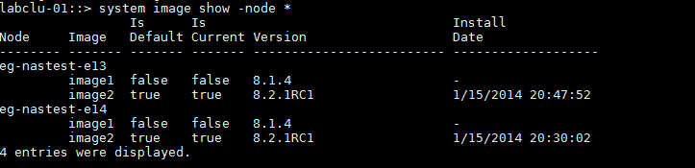

Copy and install the new image to the cluster.
Replacing the current image which is not the default or currently running on each of the nodes. This is a background activity. To check the status of the copy and install, system node image show-update-progress -node *

Verify new image copied successfully
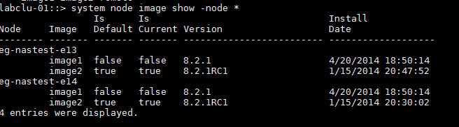

Verify storage failover is possible
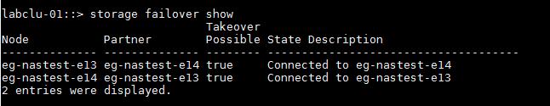

Storage failover false
- Ensure HA configuration
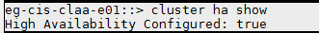n
- Toggle HA option

Disable auto-giveback on nodes

Verify auto-giveback disabled
TR standard is to disable auto-giveback on all new nodes.
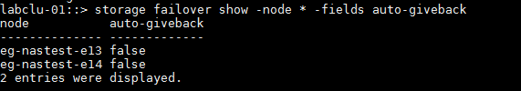

Disabling Auto-giveback
In the event that auto-giveback has not been disabled, this option should remain after upgrade has completed.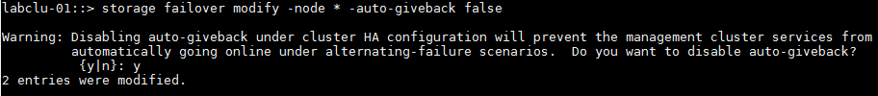

Disable Auto-Support

Trigger ASUP Log before Disabling

Disable auto-support
Failovers activities trigger ASUP to NetApp this can be prevented through disabling ASUP and re-enabling after the upgrade activity has completed

Verify ASUP was successfully disabled.
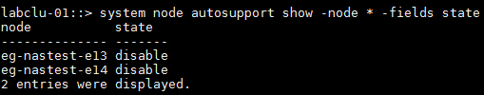

Suspend Snapmirror Operations
Suspend snapmirror operations for each node that contains destination volumes. Failing to suspend operations will may result in failed transfers. It should be noted that snapmirror operations can only exist between nodes which have equal versions of CDOT or CDOT versions are one realase greater than each other. To view existing jobs issue the command, job show.

Verify Cluster is in quorum
Before upgrading the operator should ensure that all nodes are in quorum and the per-rin quorum master is the same across all the nodes.
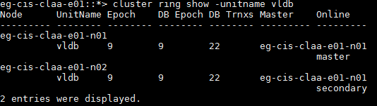

Completing the Upgrade
Section 4 should be completed for each remaining node of the cluster. Remembering to return interfaces to their home nodes after giveback is complete. Netapp should be contacted immediately if discovering the upgrade returns any status other than complete.

Migrate Interfaces

Migrating Node Interfaces
Node interfaces must be migrated away from the node. If the operator is connected to the cluster to through the cluster management LIF and this node currently hosts the cluster management LIF the operator ssh session will be disconnected while the migration activity occurs.

Verify all of the interfaces have migrated from cluster that is not currently being upgraded.
The following command will show all of the interfaces and if they are currently home; the ones that were just migrated should show false. In the event the operator is unable to migrate the LIFS ensure that the LIFS are administratively up, toggle setting if necessary from the advanced privilege mode.
net interface modify -vserver eg-cis-claa-e01 -status-admin
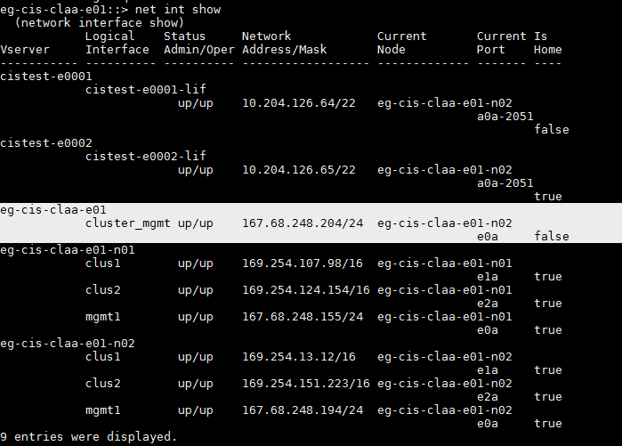

Change default image

Define default image
Redefining the default image will force the node to boot the default at the next clean system restart.
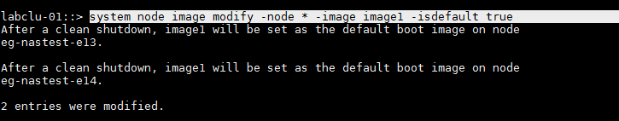

Verify new image has been set as default.
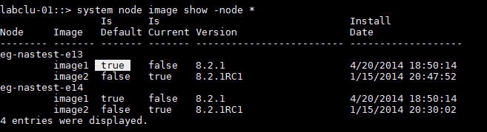

Initiate Failover

Initiating failover
The system update occurs when the first node is taken over and reboots with the new software image. The operator should wait for approximately 8 minutes. This gives the

Verify failover has occurred
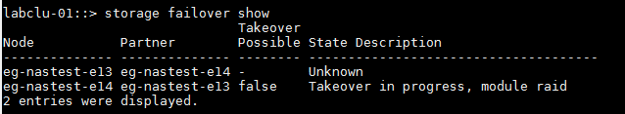

Monitoring the node during takeover
The upgrade progress and reboot of the node which has been failed over can be monitored from the SP.

Wait for system to enter giveback state
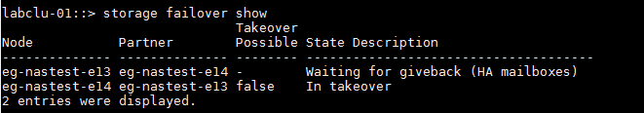

Initiate giveback of Node
In the event the giveback is not initiated, an event is generated or the operator receives and error messages due to long running operations, operations that cannot be restarted, or error conditions. The operator should address the condition described in the error message making sure to terminate any identified operations before reentering the giveback command. Veto’s can be overridden manually by entering the following command in the event messages are not relevant to the TR environment.
storage failover giveback –ofnode nodenameA -override-vetoes true

Verify giveback complete
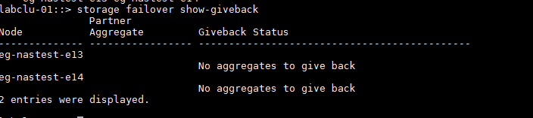

Revert interfaces to home nodes

Verify upgrade completed successfully
This command can only be run after setting privilege mode to “advanced”.
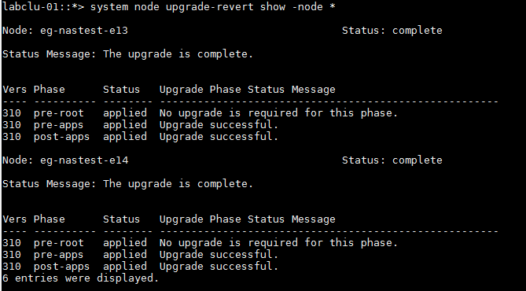

Post upgrade checks

Confirm Nodes running new CDOT version
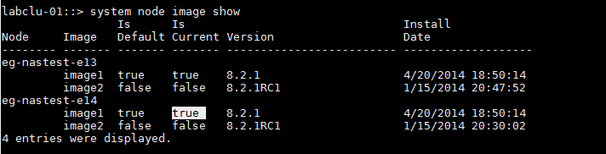

Re-enable Auto Support
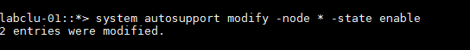

Verify all ports being utilized are administratively up
